SIMATS ENGINEERING
ASSESSMENT TOOL 1

COURSE NAME: Database Management Systems COURSE CODE: CSA05

COURSE OUTCOME COVERED

CO5: Implement database operations using query processing, optimization, and transaction management to ensure consistency and reliability. (BL3, BL4)

Activity Tool : Constraint-Based Problem Solving
(High) Assessment Tool Weightage:40%

QUESTIONS
Q.No | Question | Bloom's Level
1 | Given a complex SQL query with nested joins and sub-queries, draw the query execution plan and apply heuristic optimization rules step-by-step. | BL4 – Analyze
2 | Apply cost-based optimization to choose between nested-loop join, sortmerge join, and hash join for the given relations with specified tuple counts and page sizes. | BL4 – Analyze
3 | Implement JDBC connectivity in Java to a MySQL database and write code to execute parameterized queries with PreparedStatement. | BL3 – Apply
4 | Given a schedule of four concurrent transactions, determine whether it is conflict-serializable using a precedence graph. | BL4 – Analyze
5 | Demonstrate the application of Basic Two-Phase Locking (2PL) on a given transaction set. Identify and resolve any deadlocks. | BL3 – Apply
6 | Apply the Wait-Die and Wound-Wait timestamp-based deadlock prevention schemes on a given set of transactions requesting locks. | BL4 – Analyze
7 | Given transaction logs with checkpoints, apply the Immediate Update recovery protocol to recover the database after a system failure. | BL3 – Apply
8 | Apply Deferred Update (NO-UNDO/REDO) recovery technique on a given log file with committed and uncommitted transactions. | BL3 – Apply
9 | Design a concurrency control mechanism using strict 2PL for a banking system where T1 transfers funds and T2 reads balance simultaneously. | BL4 – Analyze
10 | Write pseudocode for query optimization using heuristics: push down selection, project early, and order joins by smaller intermediate results. | BL4 – Analyze

Code of Conduct:

I Pragadish R(192572030)(Name / Reg No) certify that this submission is my original work and that I have adhered to the guidelines specified for this assessment.
I understand that any violation of academic integrity rules will result in disciplinary action.

Signature of the student:
Pragadish R(192572030)

QUESTION 1 — QUERY EXECUTION PLAN AND HEURISTIC OPTIMIZATION

AIM

To analyze and optimize a complex SQL query involving joins and subqueries by constructing its query execution plan and applying heuristic optimization techniques such as selection pushdown, projection pushdown, and reduction of intermediate results.

PROBLEM UNDERSTANDING

Consider the following relations:

Department (Dept_ID, Dept_Name)

Employee (Emp_ID, Emp_Name, Dept_ID, Salary)

Project (Project_ID, Project_Name, Dept_ID)

Employee_Project (Emp_ID, Project_ID)

The objective is to retrieve the details of employees who satisfy the following conditions:

The employee belongs to the IT department.

The employee's salary is greater than ₹50,000.

The employee is associated with at least one project.

CONSTRAINT ANALYSIS

The following constraints should be considered while optimizing the query:

Only employees belonging to the IT department should be selected.

The employee's salary must be greater than ₹50,000.

Unnecessary tuples should be eliminated as early as possible.

Only the required attributes should be retained during query processing.

Join operations should be performed after reducing the size of the relations.

Nested subqueries should be simplified or replaced with efficient operations whenever possible.

The optimized query execution plan should reduce intermediate results and overall processing cost.

Original SQL Query

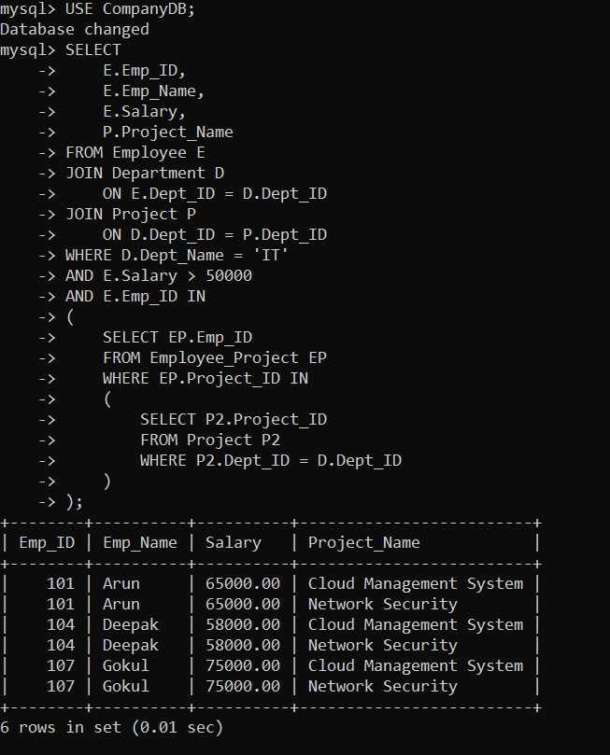

INITIAL QUERY EXECUTION PLAN

SELECT
|
JOIN
/ \
JOIN Project
/ \
Employee Department
|
Selection
Salary > 50000
|
Nested Subquery
|
Employee_Project
|
Project

HEURISTIC OPTIMIZATION

Step 1 — Push Selection Down

The conditions should be applied directly to their respective base relations.
σ Salary > 50000 (Employee)
and

σ Dept_Name = 'IT' (Department)

This eliminates unwanted tuples before the join.

Step 2 — Push Projection Down

Only attributes required for further operations are retained.
For Employee:
π Emp_ID, Emp_Name, Salary, Dept_ID(Employee) For Department:
π Dept_ID(Department) For Project:
π Project_ID, Project_Name, Dept_ID(Project)

Step 3 — Reduce Intermediate Relations
The filtered Employee and Department relations are joined first.
Employee_Filtered
|
JOIN
/ \
Department_IT

The resulting smaller relation is then joined with Project.

OPTIMIZED RELATIONAL ALGEBRA

π Emp_ID, Emp_Name, Salary, Project_Name
|
JOIN
/ \
/ \
Employee' Project'
|
JOIN
/ \
Employee' Department'
| |
σ Salary>50000 σ Dept_Name='IT'
| |
Employee Department

OPTIMIZED SQL QUERY

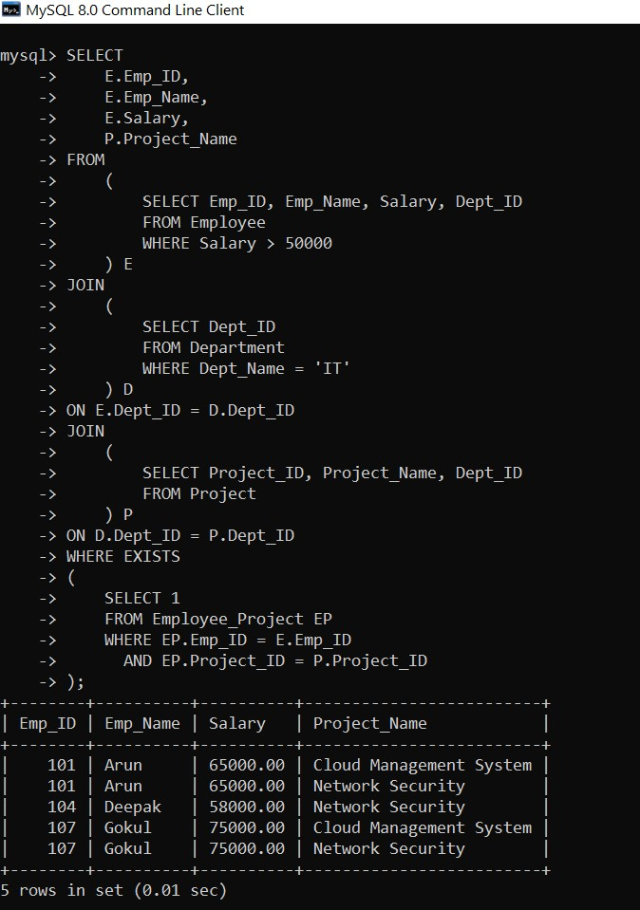

QUESTION 2 — COST-BASED QUERY OPTIMIZATION

AIM
To compare the costs of Nested-Loop Join, Sort-Merge Join, and Hash Join and select the most efficient join algorithm based on estimated I/O cost.

PROBLEM UNDERSTANDING

For illustration, consider:

Relation | Number of Tuples | Tuples/Page | Pages
R | 10,000 | 100 | 100
S | 50,000 | 100 | 500

Therefore:

B(R) = 100 pages
B(S) = 500 pages

CONSTRAINT ANALYSIS

The selection of the join algorithm depends on:

- Number of tuples.
- Number of pages.
- Available buffer memory.
- Join condition.
- Estimated I/O operations.
- Size of intermediate results.

NESTED-LOOP JOIN

For a simple page-oriented nested-loop join:
Cost = B(R) + B(R) × B(S)
Therefore:

= 100 + (100 × 500)
= 50,100 I/Os
Nested-Loop Join = 50,100 I/Os

BLOCK NESTED-LOOP JOIN

Assume 12 buffer pages.

Cost = B(R) + ceil(B(R)/(M-2)) × B(S)
= 100 + ceil(100/10) × 500
= 100 + 10 × 500
= 5,100 I/Os

SORT-MERGE JOIN

Approximate sorting and merging cost:

Sorting R ≈ 400 I/Os
Sorting S ≈ 2000 I/Os
Merge = 100 + 500 = 600 I/Os

Therefore:

Total ≈ 400 + 2000 + 600
= 3000 I/Os

HASH JOIN

For a two-pass hash join:

Cost ≈ 3(B(R) + B(S))
= 3(100 + 500)
= 1,800 I/Os

COST COMPARISON

Join Method | Estimated Cost
Nested-Loop Join | 50,100 I/Os
Block Nested-Loop Join | 5,100 I/Os
Sort-Merge Join | 3,000 I/Os
Hash Join | 1,800 I/Os

DECISION

Hash Join < Sort-Merge Join < Block Nested-Loop < Nested-Loop
Therefore, Hash Join is selected.
QUESTION 3 — JDBC CONNECTIVITY USING PREPAREDSTATEMENT

AIM
To establish JDBC connectivity between a Java application and a MySQL database and execute parameterized SQL queries using PreparedStatement.

PROBLEM UNDERSTANDING

The application must:

- Connect Java to MySQL.
- Create a database connection.
- Execute parameterized queries.
- Retrieve the result.
- Close database resources properly.

RELATION

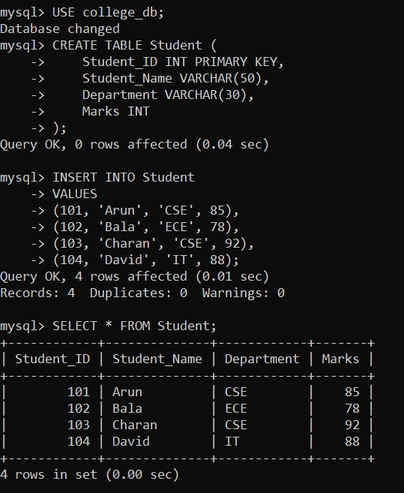

PARAMETERIZED QUERY

SELECT * FROM Student
WHERE Department = ?
AND Marks > ?;

JAVA JDBC PROGRAM

import java.sql.*;

public class JDBCExample {

public static void main(String[] args) {

String url = "jdbc:mysql://localhost:3306/college_db";
String username = "root"; String password = "your_password";
try {
Class.forName("com.mysql.cj.jdbc.Driver");

Connection con =
DriverManager.getConnection(url, username, password);

System.out.println("Database connected successfully.");

String sql =
"SELECT * FROM Student " +
"WHERE Department = ? AND Marks > ?";
PreparedStatement ps = con.prepareStatement(sql);

ps.setString(1, "CSE"); ps.setInt(2, 80);

ResultSet rs = ps.executeQuery();
while (rs.next()) {
System.out.println( rs.getInt("Student_ID") + " " + rs.getString("Student_Name") + " " + rs.getString("Department") + " " + rs.getInt("Marks")
);
}

rs.close(); ps.close(); con.close();

} catch (Exception e) {
e.printStackTrace();
}
}
}

EXPECTED OUTPUT

Database connected successfully.
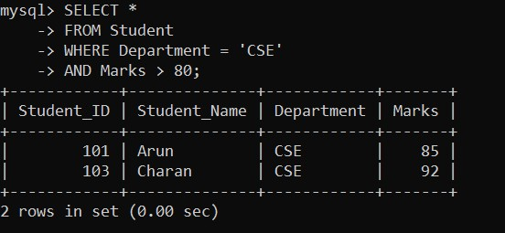

APPLICATION OF PREPAREDSTATEMENT

ps.setString(1, "CSE"); ps.setInt(2, 80);

QUESTION 4 — CONFLICT SERIALIZABILITY

AIM
To determine whether a concurrent schedule of four transactions is conflict-serializable by constructing and analyzing its precedence graph.

PROBLEM UNDERSTANDING

Consider the following transactions:
T1: R1(A) W1(A) R1(B) W1(B)
T2: R2(A) W2(A)
T3: R3(B) W3(B)

T4: R4(A) R4(B)

Consider the interleaved schedule:

R1(A)
W1(A)
R2(A)
W2(A)
R3(B)
W3(B)
R1(B)
W1(B)
R4(A)
R4(B)

CONSTRAINT ANALYSIS

Two operations conflict when:

- They belong to different transactions.
- They access the same data item.
- At least one operation is a write.

CONFLICT IDENTIFICATION

For data item A:
W1(A) → R2(A)
W1(A) → W2(A)

Therefore:

T1 → T2

For data item B:

W3(B) → R1(B)
W3(B) → W1(B)

Therefore:

T3 → T1

For T4:

T1 → T4
T2 → T4
T3 → T4

PRECEDENCE GRAPH

T3 ─────→ T1 ─────→ T2

│ │ │

│ ↓ ↓

└────────→ T4 ←────┘
Edges:
T1 → T2
T3 → T1
T1 → T4
T2 → T4
T3 → T4

CYCLE ANALYSIS

There is no cycle in the graph.
Therefore:
Schedule is conflict-serializable.

One possible equivalent serial order is:

T3 → T1 → T2 → T4

QUESTION 5 — BASIC TWO-PHASE LOCKING

AIM
To demonstrate the application of Basic Two-Phase Locking (2PL), identify a deadlock using a wait-for graph, and resolve the deadlock.

PROBLEM UNDERSTANDING

Consider two transactions:
T1: Read A → Write A → Read B

T2: Read B → Write B → Read A

Exclusive locks are required for write operations.

TWO PHASES OF 2PL

Growing Phase

A transaction can acquire locks but cannot release them.

Shrinking Phase

A transaction can release locks but cannot acquire new locks.

LOCK ACQUISITION

Initially:

T1: LOCK-X(A)
T2: LOCK-X(B)

Now T1 requests B:

T1 → WAIT

because T2 holds B.
T2 requests A:
T2 → WAIT

because T1 holds A.

DEADLOCK IDENTIFICATION
Current state:

T1 holds A
T2 holds B

T1 waits for B
T2 waits for A

Wait-For Graph

T1 ──────► T2
▲ │
│ ▼
└─────────┘
This produces:
T1 → T2 → T1

Hence, a deadlock exists.

DEADLOCK RESOLUTION
Abort one transaction, for example:
ABORT T2
Release T2's lock:

UNLOCK(B)

T1 can now acquire B:
LOCK-X(B)
T1 completes:
COMMIT T1

2PL LOCKING SEQUENCE

T1:

LOCK-X(A)

LOCK-X(B)
READ(A)
WRITE(A)
READ(B)
WRITE(B)
COMMIT
UNLOCK(A)
UNLOCK(B)

QUESTION 6 — WAIT-DIE AND WOUND-WAIT

AIM
To apply the Wait-Die and Wound-Wait timestamp-based deadlock prevention techniques to transactions requesting conflicting locks.

TRANSACTION TIMESTAMPS

Consider:

T1 timestamp = 5
T2 timestamp = 10

Smaller timestamp indicates an older transaction.
Therefore:
T1 = Older
T2 = Younger

WAIT-DIE SCHEME

Rule

- Older requests a lock held by younger → Wait
- Younger requests a lock held by older → Die/Abort

Case 1
T1 requests a resource held by T2.

Since T1 is older:

T1 → WAIT

Case 2

T2 requests a resource held by T1.
Since T2 is younger:

T2 → ABORT

WOUND-WAIT SCHEME

Rule

- Older requests a lock held by younger → Abort younger
- Younger requests a lock held by older → Wait

Case 1
T1 requests a resource held by T2.
T1 is older:
T2 → ABORT
T1 → GETS RESOURCE

Case 2

T2 requests a resource held by T1.
T2 is younger:
T2 → WAIT

COMPARISON

Condition | Wait-Die | Wound-Wait
Older requests younger's lock | Wait | Abort younger
Younger requests older's lock | Abort | Wait

QUESTION 7 — IMMEDIATE UPDATE RECOVERY

AIM
To apply the Immediate Update recovery protocol using transaction logs and checkpoints after a system failure.

PROBLEM UNDERSTANDING

In immediate update:

- Database changes may occur before commit.
- Log records contain old and new values.
- Committed transactions must be REDO.
- Uncommitted transactions must be UNDO.

TRANSACTION LOG
For illustration:

<START T1>
<T1, A, 100, 150>

<START T2>
<T2, B, 200, 250>

<COMMIT T1>

<CHECKPOINT>

<START T3>
<T3, C, 300, 350>

<START T4>
<T4, D, 400, 450>
<COMMIT T4>
SYSTEM FAILURE

TRANSACTION STATUS

Transaction | Status | Recovery Action
T1 | Committed | REDO
T2 | Uncommitted | UNDO
T3 | Uncommitted | UNDO
T4 | Committed | REDO

REDO OPERATIONS

T1
A: 100 → 150

Therefore:
A = 150

T4

D: 400 → 450

Therefore:

D = 450

UNDO OPERATIONS

T2
B: 200 → 250

Restore old value:

B = 200

T3

C: 300 → 350

Restore old value:

C = 300

FINAL DATABASE STATE

- = 150
- = 200
- = 300
- = 450

QUESTION 8 — DEFERRED UPDATE RECOVERY

AIM
To apply the Deferred Update (NO-UNDO/REDO) recovery technique to recover a database containing committed and uncommitted transactions.

PROBLEM UNDERSTANDING

In deferred update:

- Database modifications are postponed until the transaction commits.
- Uncommitted changes are not present in the database.
- Therefore, UNDO is unnecessary.
- Committed transactions are REDONE after failure.

TRANSACTION LOG

<START T1>
<T1, A, 100, 150>

<START T2>
<T2, B, 200, 250>

<COMMIT T1>
<START T3>
<T3, C, 300, 350>

SYSTEM FAILURE

TRANSACTION STATUS

T1 → COMMITTED
T2 → UNCOMMITTED T3 → UNCOMMITTED

RECOVERY ANALYSIS
T1 T1 committed before failure.
Therefore:
REDO T1 A = 150

T2

T2 did not commit.
Therefore:
IGNORE T2

T3

T3 did not commit.
Therefore:
IGNORE T3

RECOVERY TABLE

Transaction | Status | Action
T1 | Committed | REDO
T2 | Uncommitted | Ignore
T3 | Uncommitted | Ignore

FINAL STATE

- = 150
- = 200
- = 300

QUESTION 9 — STRICT 2PL FOR BANKING SYSTEM

AIM
To design a concurrency-control mechanism using Strict Two-Phase Locking (Strict 2PL) for a banking system where one transaction transfers funds while another transaction reads the balance.

PROBLEM UNDERSTANDING

Consider two accounts:

Account A = ₹10,000
Account B = ₹5,000

Transaction T1 transfers:

₹2,000 from A to B

Transaction T2 reads the balances simultaneously.

CONSTRAINTS

The system must ensure:

- No dirty reads.
- No inconsistent balance.
- Transfer must be atomic.
- Write locks must remain until commit.
- T2 should not read intermediate values.

TRANSACTION T1 — FUND TRANSFER

T1:
LOCK-X(A)
LOCK-X(B)

- = A - 2000
- = B + 2000
COMMIT
UNLOCK(A)
UNLOCK(B)

After the transfer:

- = ₹8,000
- = ₹7,000

TRANSACTION T2 — BALANCE READING

T2:
LOCK-S(A)
LOCK-S(B)

READ(A)
READ(B)

COMMIT

UNLOCK(A)
UNLOCK(B)

CONCURRENT EXECUTION

Initially:

- = ₹10,000
- = ₹5,000
T1 obtains:
X-lock(A)
X- lock(B)
T1 performs the transfer:

- = ₹8,000
- = ₹7,000

T2 requests shared locks:

S-lock(A)
S-lock(B)

Since T1 still holds exclusive locks:
T2 → WAIT
T1 commits:

COMMIT T1

T1 releases its locks.

T2 then obtains shared locks and reads:

- = ₹8,000
- = ₹7,000

SQL IMPLEMENTATION

T1
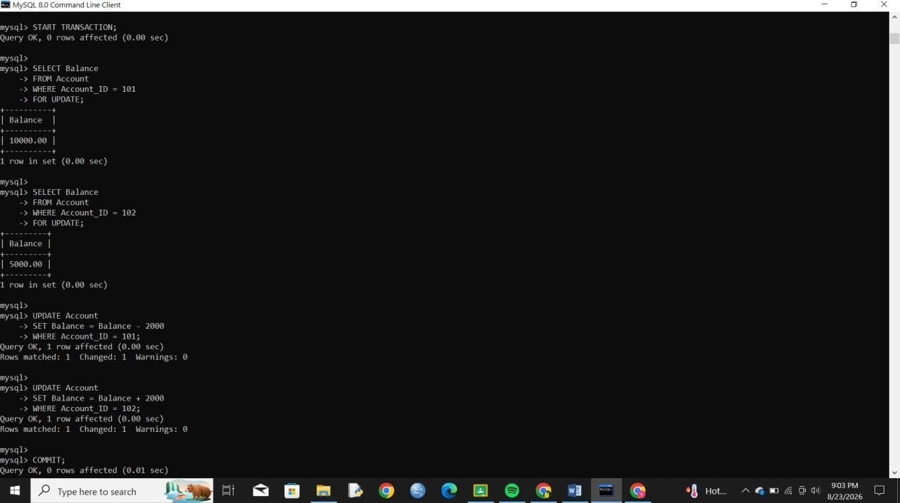

T2

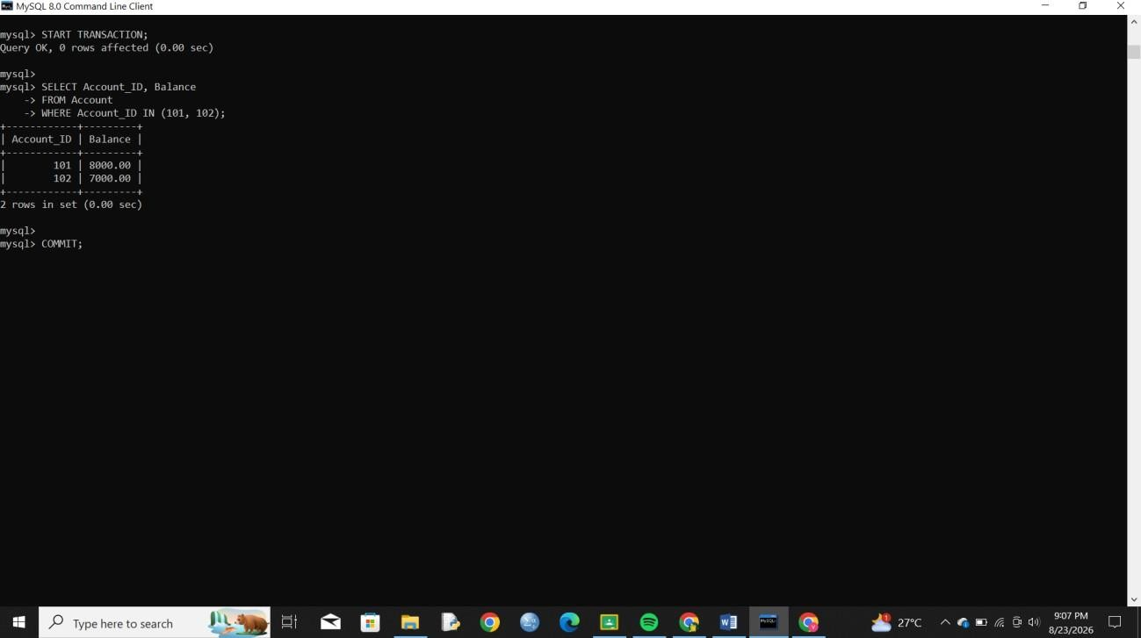

QUESTION 10 — HEURISTIC QUERY OPTIMIZATION PSEUDOCODE

AIM
To develop pseudocode for query optimization using selection pushdown, early projection, and join ordering based on smaller intermediate results.

PROBLEM UNDERSTANDING

The objective is to minimize query-processing cost by reducing:

- number of tuples,
- number of attributes,
- size of intermediate relations.

CONSTRAINT ANALYSIS

The optimizer must:

- Push selections toward base relations.
- Retain only required attributes.
- Estimate intermediate relation sizes.
- Perform smaller joins first.
- Generate an optimized query plan.

HEURISTIC RULE 1 — SELECTION PUSH DOWN

A selection condition involving only one relation should be moved close to that relation.
Example:
σ Salary > 50000(Employee)

HEURISTIC RULE 2 — PROJECT EARLY

Only attributes needed by later operations should be retained.
For Employee:
π Emp_ID, Emp_Name, Dept_ID(Employee) For Department:
π Dept_ID(Department)

HEURISTIC RULE 3 — ORDER JOINS

Joins producing smaller intermediate relations should be performed earlier.

PSEUDOCODE

ALGORITHM HEURISTIC_QUERY_OPTIMIZER(Query)

BEGIN

Parse Query

Construct initial relational algebra tree
FOR each selection condition
Identify the relation containing the required attributes

IF condition involves only one relation THEN Push selection to that relation
END IF END FOR
FOR each relation

Identify attributes required by:

SELECT
WHERE
JOIN

Remove unnecessary attributes

Push projection toward base relation
END FOR
Estimate the size of each intermediate relation
WHILE unprocessed joins exist
Select the join that produces the smallest intermediate relation Perform the selected join
Recalculate intermediate result size
END WHILE

Generate optimized execution plan RETURN optimized plan

END

OPTIMIZED EXECUTION PLAN

Final Projection
|
JOIN
/ \
/ \
Employee ⋈ IT Dept Project
|
σ Salary > 50000
|
Employee

IT Department:
σ Dept_Name = 'IT'
|
Department

